

**FNDB020 Accounting**

**Student Workbook**

Lecture and Tutorial

**Week 6: Ethics & Business Entities**

**Updated March 2018**

# Role of Ethics in Accounting and Business

**Business Ethics** are



## EXHIBIT 1: CASES ON ACCOUNTING AND BUSINESS FRAUDS

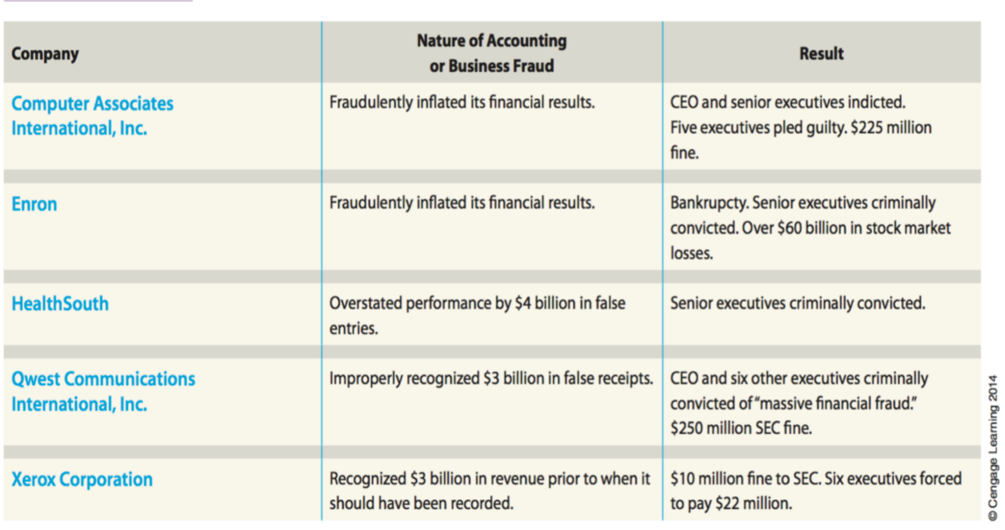

(source: C.Warren, J.Reeve, J.Duchac, Accounting 25E, Cengage Learning)

## What went wrong ?

1. *Failure of Individual Character*.
2. *Culture of Greed and Ethical Indifference..*

## Ethics and Governance

The success of a business today is greatly influenced by how society views the ethical behaviour of the business.

**Corporate Social Responsibility** (CSR) and, CSR requires that Managers and employees must behave in an ethical manner in managing and operating a business.

## Responsible Financial Reporting

Accountants and persons responsible for preparing financial statements must also behave in an ethical manner so that the information they provide will be trustworthy and useful for making decisions that improve the business. Otherwise, no one will be willing to invest in or loan money to the business

.

## Triple bottom line means ….

## Note the Fundamental Principles of Professional Conduct



## What does ethical behaviour mean? *(source: HEM, 9E p23)*

Ethical conduct can be considered important to a business’ *long-term survival* because:

1. It attracts a regular and stable client base;
2. Unethical (illegal) conduct may prove to be costly;
3. It may attract shareholders and/or consumers in that they trust you to manage the money successfully and/or provide a quality service; and
4. Unethical conduct can lead to government intervention and even closure of the business.

**(source: HEM, 9E pg 30)**

## Ethical practices among friends

*Two friends, Becks and Vicky, had just started university studies. Both intended to major in accounting. During the first week of lectures, Vicky, who had to go home for family reasons, asked Becks to buy a copy of the prescribed accounting text for her from the university bookshop. She left Becks $100 to cover the cost of the text currently selling in the bookshop for $80.*

*On the day Becks visited the bookshop to buy the text, and managed to get second-hand copies. These returned copies had been marked down to $65 and looked new. Becks realised that he could give Vicky change of $20 and keep the savings on the text of $15 for himself. He simply had to tell Vicky that he had lost the receipt.*

***Required: (For students to read in their own time)***

1. *Identify who the* ***stakeholders*** *are in this situation.*
2. *Outline the ethical issues involved.*
3. *Discuss what you would do if you were Becks.*

## Answers: (Read to understand the analysis process)

1. The stakeholders or the involved **parties in this situation** are Becks and Vicky.

1. Becks gained $15 by buying the text at a price lower than the bookshop text price of $80. He has misled his friend Vicky by failing to disclose/inform the cost price of $65 for which represents what he paid for the textbook.

He has **not acted honestly** by retaining (keeping) the $15 cash saving. He has not **acted ethically** nor has he acted as a friend. And, in doing so may lose her friendship and trust.

He has **breached his duty** to his friend by not buying the new book at $65 and offering $15 balance in return.

1. Becks’ alternatives are:

* 1. tell Vicky what happened and give her the correct change; or
  2. buy a brand-new textbook for $80 as listed by the bookshop; or
  3. contact Vicky (if at all possible) and ask for her decision

## Ethical Case Study

Justin works as an accountant for Dodgy. His boss, Mr Greedy is part of the management team that receive a bonus depending on the profitability of the business. If Dodgy makes $10 million in profit, the owner will pay each member of the management team a bonus of $50,000.

At the end of June, it appears that Dodgy will only make a profit of $9.9 million. Mr Greedy instructed Justin to find ways of maximising the profit for the year. He suggested that some of the expenses incurred this year should not be recorded until next year.

***Required:***

1. Who are the stakeholders in this situation?
2. What are the ethical issues?
3. What would you do if you were Justin?

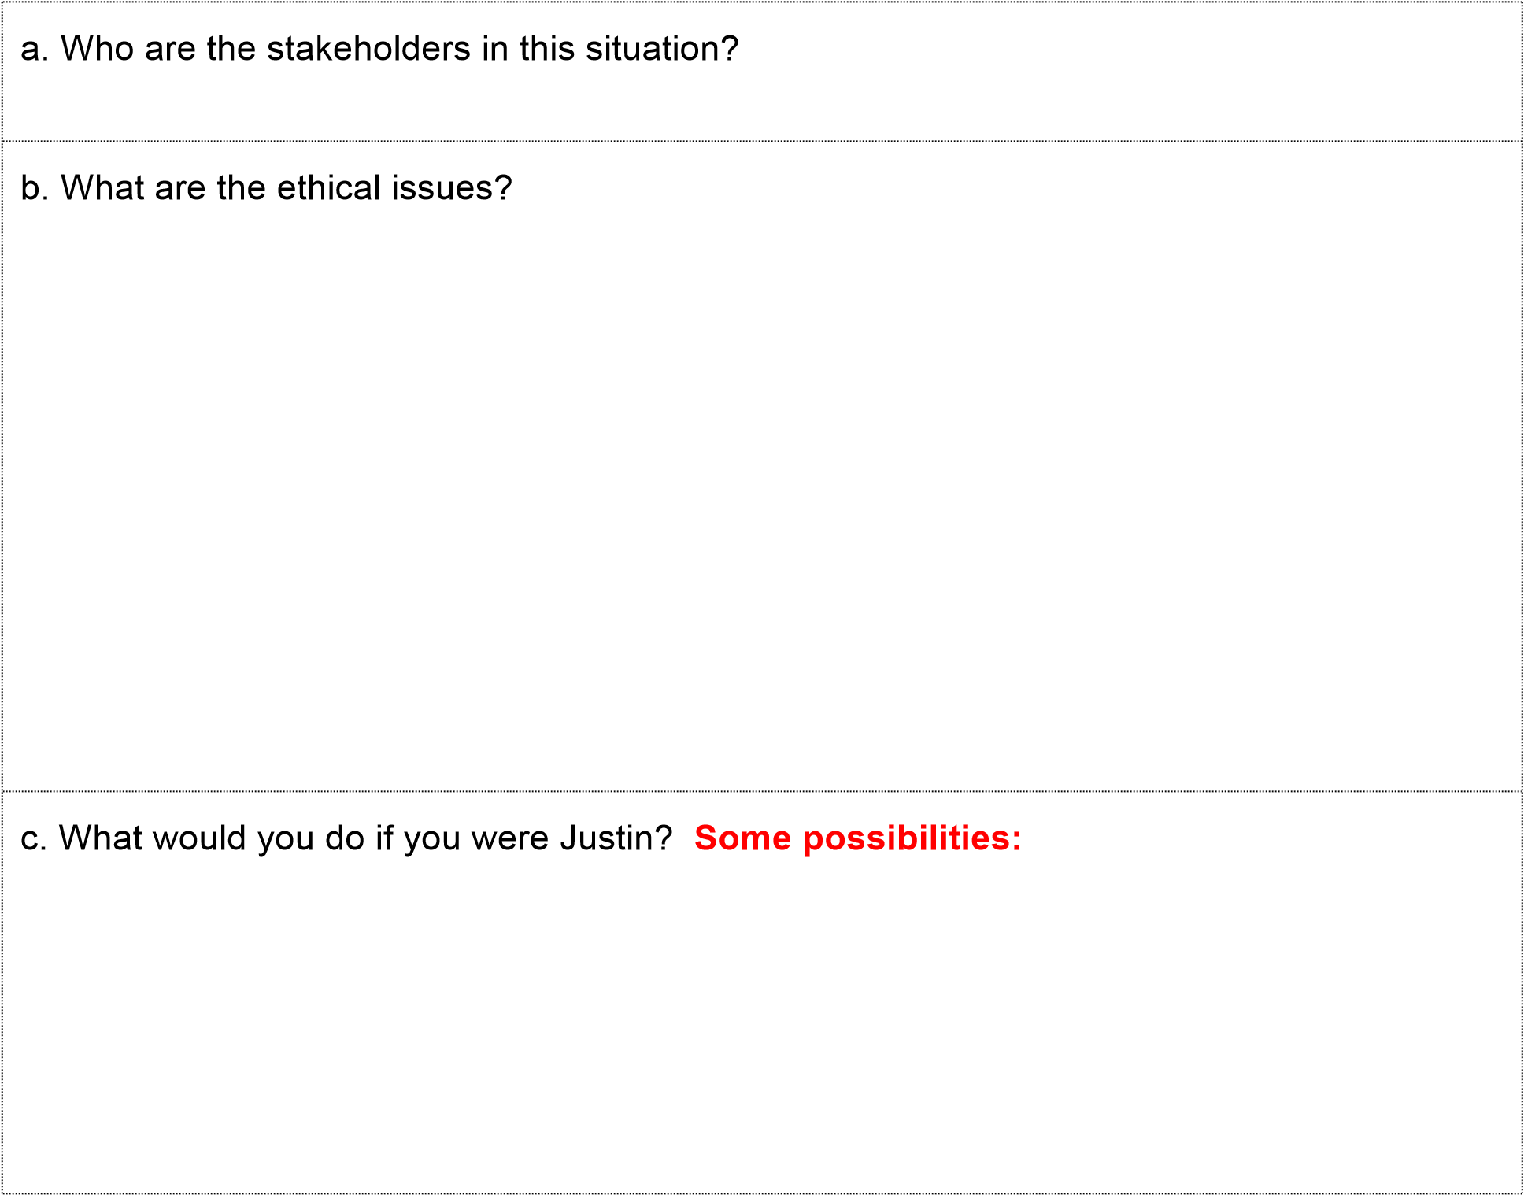

# Business Entity Concept - revisited

The three most common types for profit-seeking business entities are sole traders (or single proprietorships), partnerships and companies (or limited liability company)

11 Sole trader (or single proprietorship)

**Advantages**

* Easy and inexpensive to set up
* Fewer legal obligations to set up
* Owner has *full control* over assets
* Owner has *full claim* over business profits

**Disadvantages**

* Business is *limited* to the owner’s skill
* Business will *ceases to exist* if owner decides not to continue with the business
* The owner is *personally liable* for all business debts. (unlimited liability)

## Partnership

**Advantages**

* Enables sharing of ideas, skills and pooling
* Easy and less costly to set up than a full company
* It has less government regulation and supervision than a company
* Partners have a proportionate claim over partnership profits
* The Partnership can be used for a single purpose business venture and quickly dissolved.

**Disadvantages**

* Unlimited liability – each partner is liable for of capital resources debts of the Partnership.
* Limited life – the Partnership is easily terminated (ended)
* Creditors can look at the individual partner’s assets recovery of any unpaid claims (debts)

## *Company*

**Advantages**

* Limited Liability – shareholders are liable for debts to the extent of their issued capital.
* Separate legal entity –
* Broad source of capital –the company can attract a cheaper source of funding by issuing shares
* Continuity of existence – the company continues to exist even if the shareholders change, operations are not disrupted.
* Use of professional Management –
* Potential income tax savings – companies are allowed more tax deductions and shareholders can take advantage of the dividend imputation scheme to reduce their tax liability.

**Disadvantages**

* Greater government and regulation – a company must prepare regular financial statements (GPFS) for presentation to their members, creditors and regulatory bodies.
* Agency principal – the separation of ownership and management may result in managers may make decisions that are not for the benefit of the shareholders
* It is costly to set up and maintain –

## Summary Business Entities

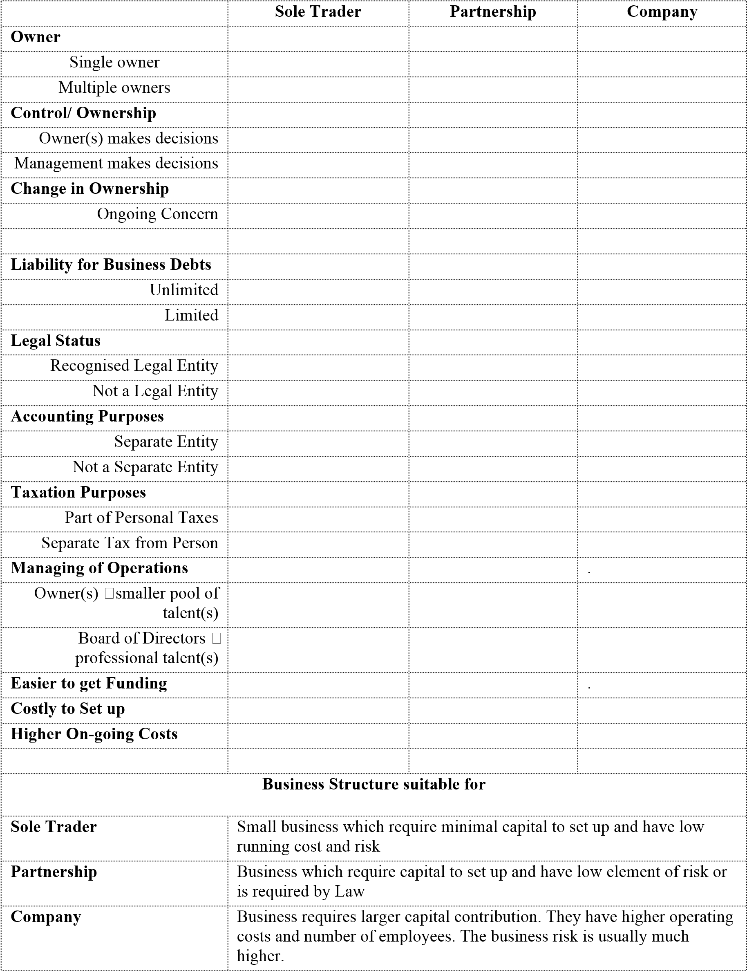

## Choose a suitable Business Structure

**CASE STUDY 1:**

Frank bought a motorcycle and uses it to start a small delivery business. He prefers the freedom of working on his own and does not want to share any business profit.

### Required

Which business entity will Frank most likely choose? Why?

**CASE STUDY 2:**

Frank is doing well and after 6 months the number of clients has increased. To grow the business Frank decides to approach a good friend called Eric whom he knows owns a van. Eric is interested in being involved in Frank’s business so they agree to the following arrangement:

1. Frank takes care of the daily operations that involve taking orders from clients and keeping proper business records.
2. Eric will be responsible for all delivery to clients.
3. They decide to share the profits equally.

### Required

Which business entity would suit Frank and Eric’s business? Why?

**CASE STUDY 3:**

After 2 years, Frank and Eric require two more vans and will now need to hire more people to help with the business. Neither Frank nor Eric can financially afford to invest more into the expanding business. The operating costs to run the business and hire more employees are starting to increase. They are concerned about the risk involved if they continue to expand under their current business partnership.

Required

**Do you recommend any changes to the current business structure? Why/why not?**

Tutorial Week 6

**DISCUSSION QUESTION SOLUTIONS**

9. *‘Why would we bother classifying assets in order of their liquidity on a statement of financial position? After all, the value placed on assets is not a true reflection of how much we could sell them for.’ Discuss.*

|  |
| --- |
| **Exercise 4.1** |

## Identifying adjusting journal entries

*Match the end-of-financial-year adjustments (for each independent situation) to the appropriate journal entry.*

*Adjustments*

1. *Portion of prepaid insurance which has now expired (been used up****)***
2. *Revenue earned but not yet received*
3. *Insurance expense which has not been used up (there is still future cover):*
4. *Portion of recognised revenue which is considered unearned*
5. *Expenses incurred but not yet paid*
6. *Revenue received in advance which is now earned:*

*Journal entry*

1. *Prepaid Insurance Dr, Insurance Expense Cr*
2. *Unearned Revenue Dr, Revenue Cr*
3. *Insurance Expense Dr, Prepaid Insurance Cr*
4. *Revenue Dr, Unearned Revenue Cr (e) Expenses Dr, Expenses Payable Cr*

*(f) Revenue Receivable Dr, Revenue Cr*

## Financial Statements

*The adjusted trial balance for Chris’ Cleaning Services.*

### CHRIS’ CLEANING SERVICES

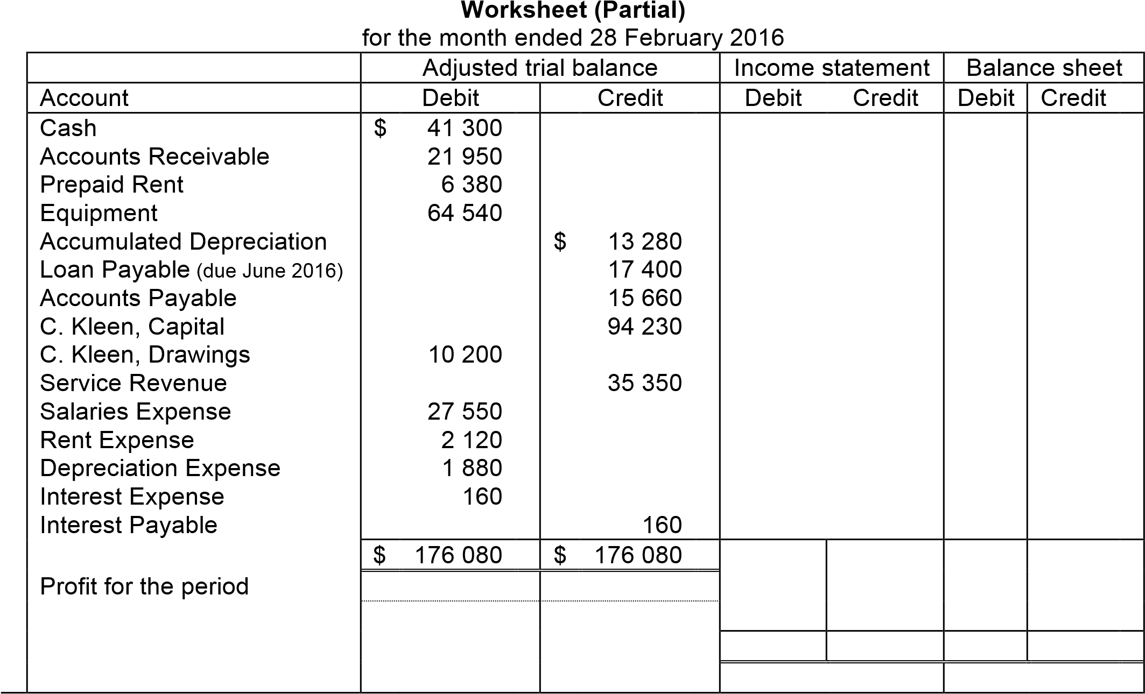

#### Required Complete the Income Statement, a Statement of Changes in Equity and a classified Balance Sheet

|  |  |
| --- | --- |
| **Exercise 5.3** | **Completion of financial statements and closing entries** |

*The following* ***unadjusted*** *trial balance was taken from the ledger of Miranda’s Management Services on 30 June 2018.*

|  |  |  |
| --- | --- | --- |
| ***Account*** | ***Debit*** | ***Credit*** |
| *Cash at bank*  *Accounts receivable*  *Prepaid insurance*  *Equipment*  *Accumulated depreciation – equipment*  *Accounts payable*  *Miranda Pike, Capital*  *Miranda Pike, Drawings*  *Service revenue*  *Wages expense*  *Electricity expense*  *Sundry expense* | *$80 000*  *74 000*  *24 000*  *230 000*        *50 000*    *130 000*  *54 000*  *26 000* | *$60 000*  *64 000*  *204 000*    *340 000* |
|  |  |  |
|  |  |  |
|  |  |  |
| *Total* | *$668 000* | *$668 000* |

#### Required

1. *using the following additional information on 30 June 201 to make adjustments :* 
   1. *Accrued wages, $18 000.*
   2. *Expired insurance, $16 000.*
   3. *Depreciation on equipment, $60 000.*
2. *Prepare an income statement, a Statement of Changes in Equity and Balance Sheet. C.*